
Company
Logotype

Cone Beam Computed Tomography- Report



Porur Dental X-rays & CBCT

Patient Name : Mr. Perumal | Date of Report : 18.04.2024
Age/ Gender : 63 years/ Male | Region of Interest : CBCT Mandible
Referring doctor: Dr. Boominathan | Indication : Implant assessment
Clinical Notes: Nil
PATIENT INFORMATION

CBCT- Mandible provided
CBCT – IMAGE DETAILS

RADIOGRAPHIC INTERPRETATION

- Partially edentulous mandibular alveolar ridge – missing teeth: 34, 35, 36, 37, 38, 45, 46, 47.
- The mandibular alveolar ridge is present with normal trabecular pattern.

IMPLANT ASSESSMENT

 | 35 region | 36 region | 37 region
Sub-Crestal (in mm) | 5.45 | 8.04 | 8.64
Mid- Crestal (in mm) | 6.97 | 11.05 | 10.35
Distance between alveolar ridge and the inferior alveolar nerve canal (in mm) | 9.44 | 11.78 | 11.82
Distance between alveolar ridge and the inferior border of mandible (in mm) | 20.18 | 20.74 | 20.59

 | 34 region | 44 region
Sub-Crestal (in mm) | 6.68 | 7.23
Mid- Crestal (in mm) | 6.12 | 8.4
Distance between alveolar ridge and the inferior border of mandible (in mm) | 15.44 | 24.26
 | 45 region | 46 region | 47 region
Sub-Crestal (in mm) | 3.72 | 7.59 | 7.45
Mid- Crestal (in mm) | 6.04 | 10.2 | 9.19
Distance between alveolar ridge and the inferior alveolar nerve canal (in mm) | 11.85 | 11.07 | 13.09
Distance between alveolar ridge and the inferior border of mandible (in mm) | 23.73 | 21.25 | 21.01

RADIOGRAPHIC IMPRESSION

- Partially edentulous mandibular alveolar ridge.

Kindly correlate with clinical findings


IMAGES FOR REFERENCE

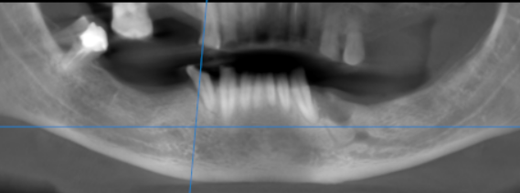

3-DIMENSIONAL VIEW

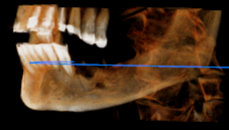

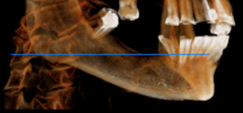

CROSS SECTIONAL VIEW

34 region | 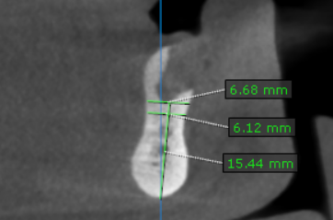
35 region | 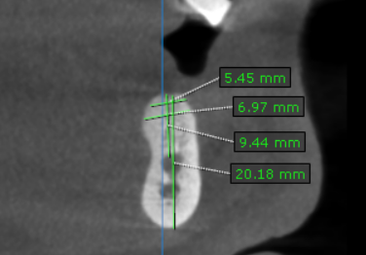
36 region | 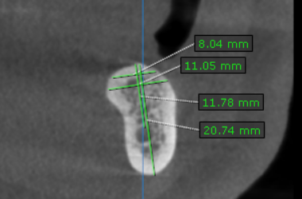
37 region | 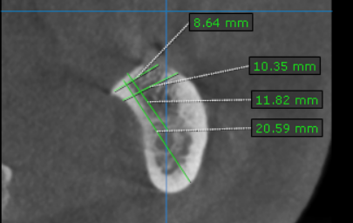
44 region | 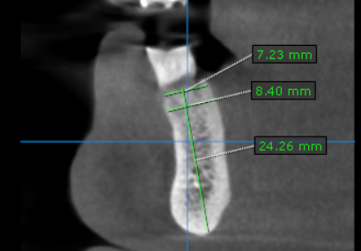
45 region | 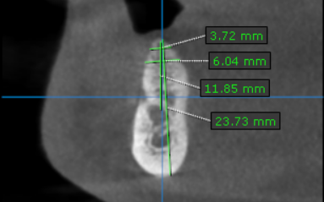
46 region | 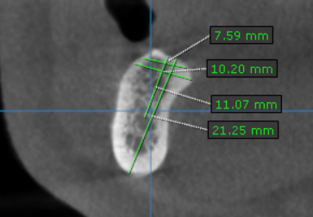
47 region | 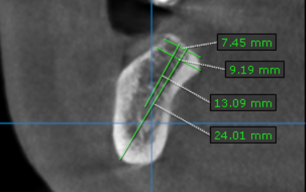

**** End of report ****

